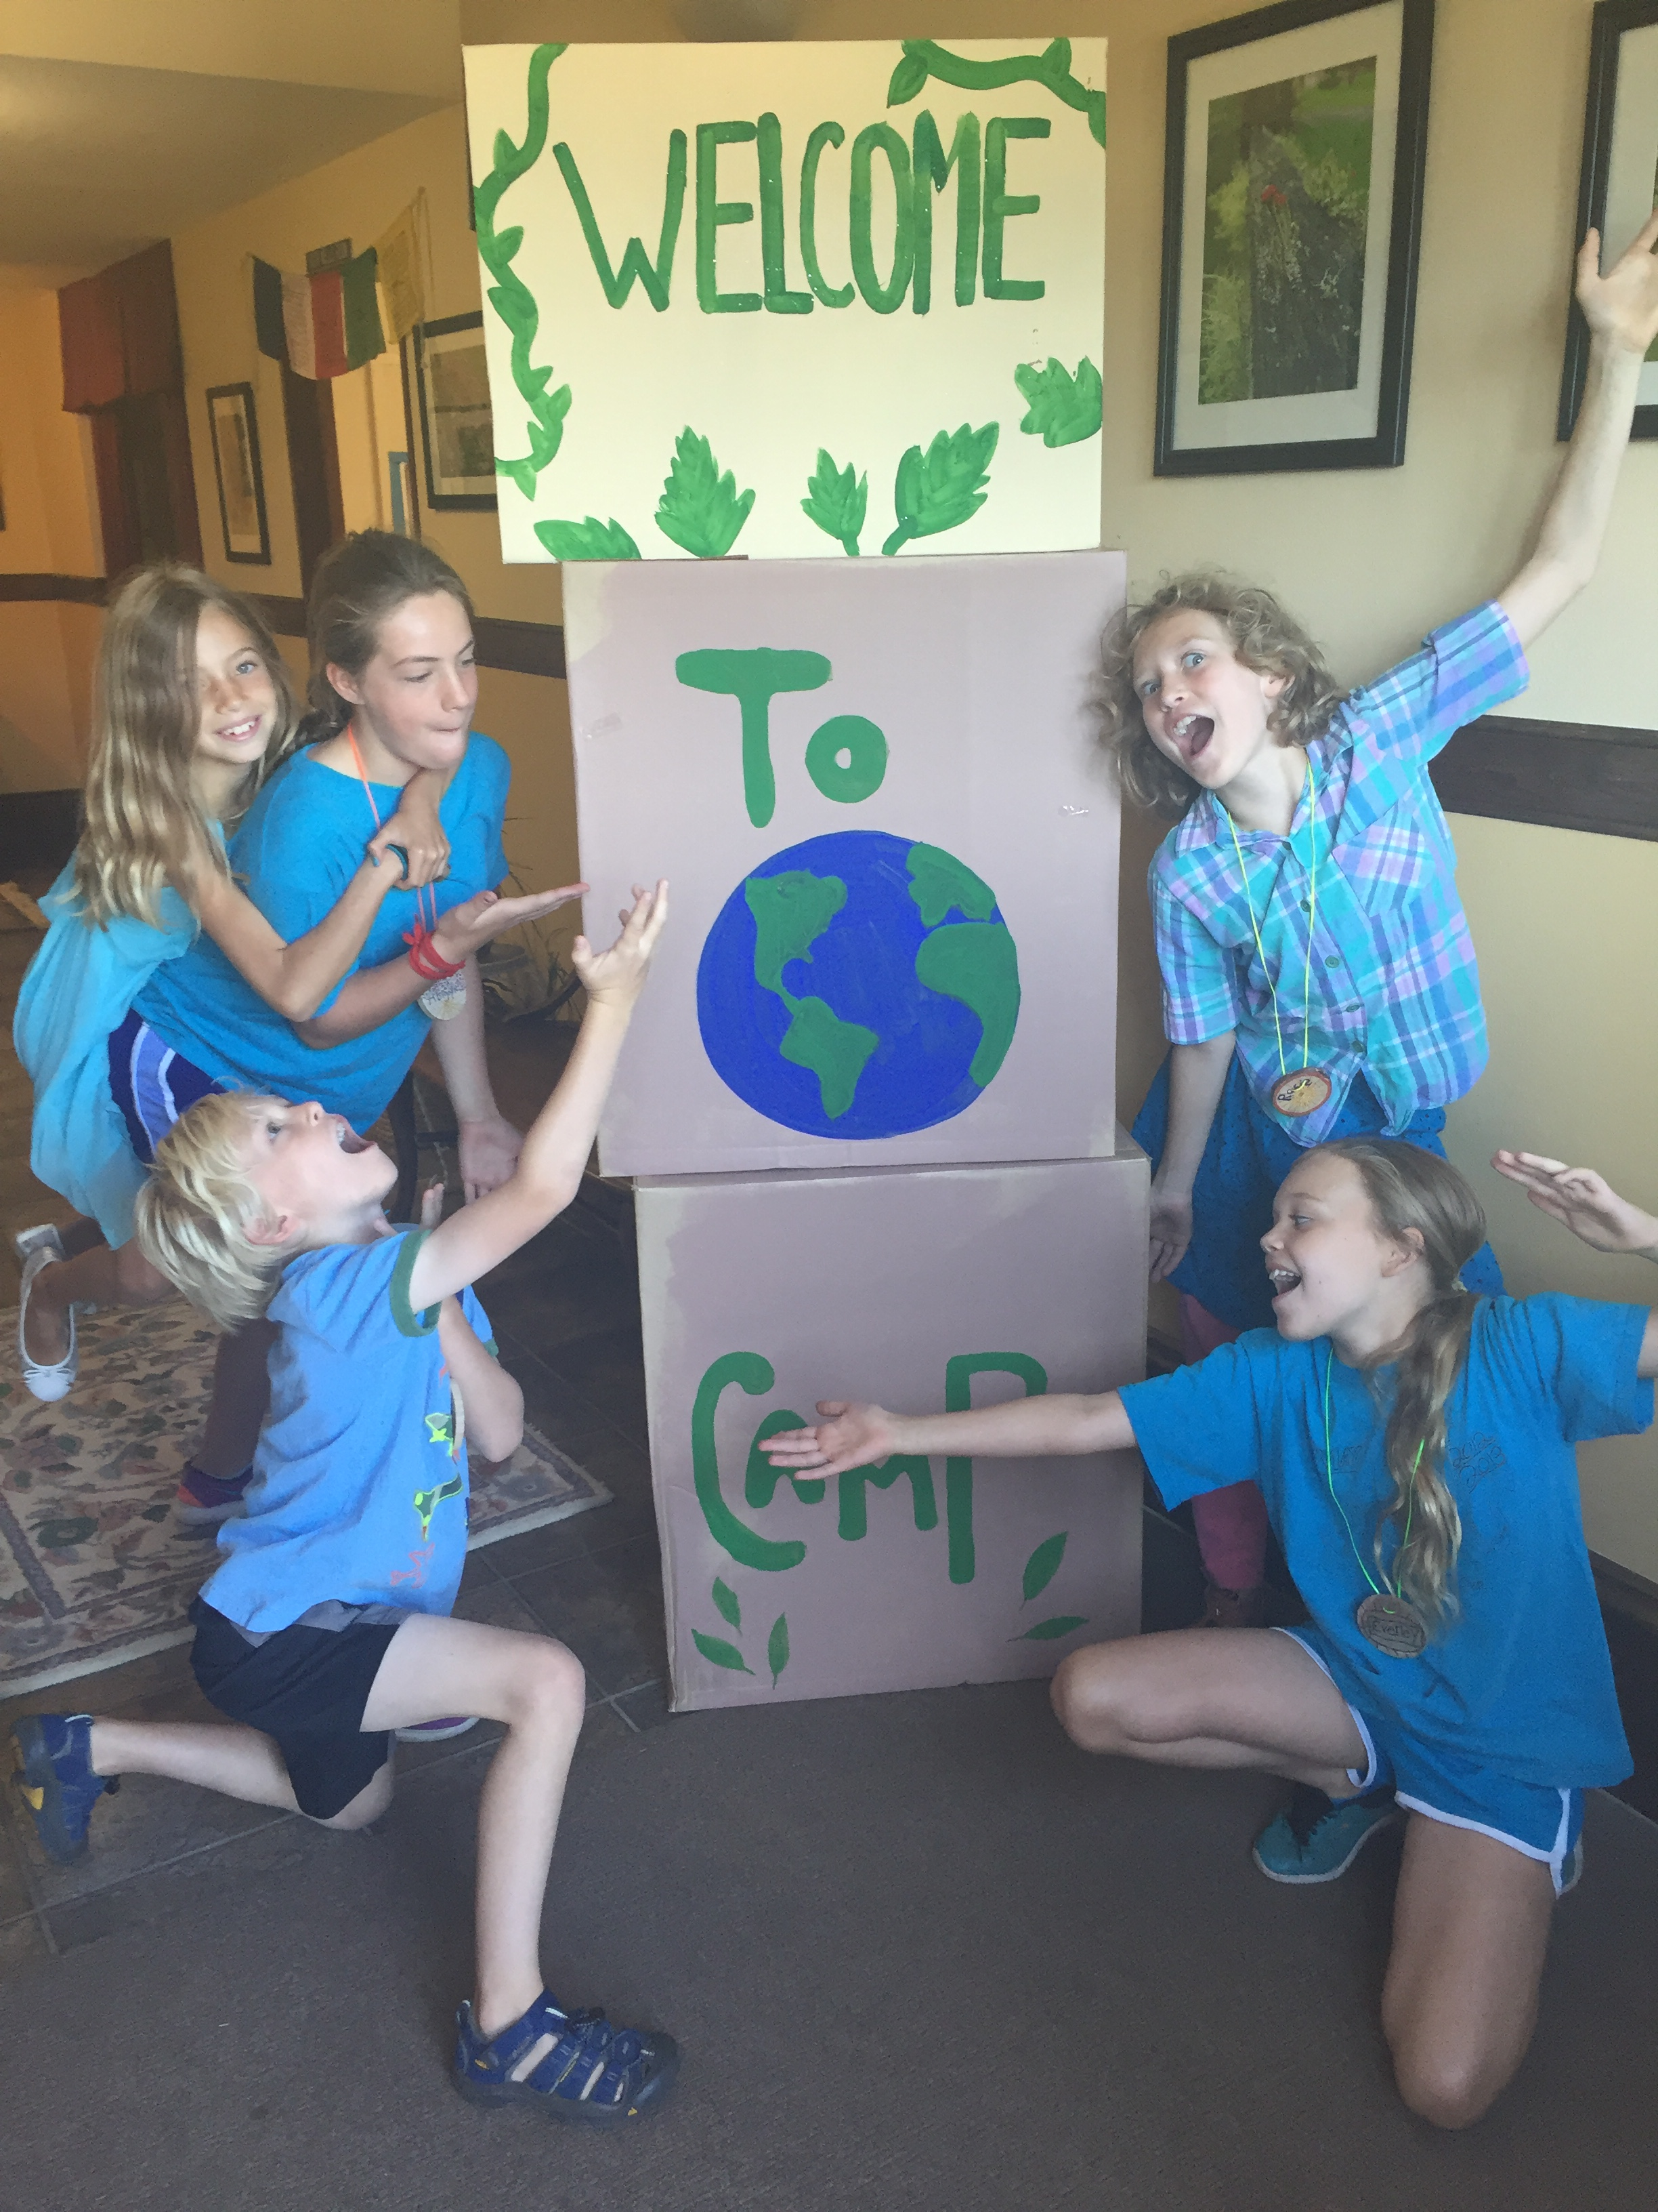
Riverside UCC Earth Camp

July 16-20 from 9am-noon
for kids entering K-5th

With a special presentation
during worship on July 22nd
This year’s
theme is
“Noah’s
Ark”

Riverside Community Church, United Church of Christ 541-386-1412 rcc@gorge.net

Dear Parents,

We are excited your child is coming to Earth Camp at Riverside church! The theme for camp this year is “Noah’s Ark”, and will be July 16-20 from 9am until noon every day. There will be a special presentation for families and our congregation on Sunday, July 22nd at 10:30am. Please sign your camper in between 8:45-9am (no drop-offs) and sign out at Noon. Campers are encouraged to come for the whole week, but daily drop-ins are welcome.
The middler and high school counselors are energized and hard at work preparing for camp along with plenty of help from our adult staff.
We have fun classes planned, including learning sign language for colors and animals, viewing the animals of Africa, taking an art walk, and making animal masks!

A typical day will look something like this:
∙Gathering story time/song ∙ rotation between three classes of crafts, games, snack in small groups∙ closing circle
Colors of the rainbow! Each day campers are invited to dress up in the colors of the rainbow:
Monday – red or orange
Tuesday – yellow
Wednesday – green
Thursday – blue or purple
Friday – tie dye, favorite color or all colors

The camp provides a healthy snack every day, but please send your child to camp having eaten a hearty protein breakfast, as we will be active all morning! If your child has allergies, please note it on the medical form. If it is a severe allergy, we may ask you to provide a snack for your child every day. Please fill out the enclosed medical form and send it to the church office prior to camp or bring it when you arrive. Each camper must have a medical form completed before the start of camp.

Early Bird registration Discount deadline is Sunday, July 1st

Thank so much! it’s going to be a great camp. If you have any questions or concerns, please feel free to call me at the church office: 541-386-1412.

Warmly,

Elaine Thompson
Director of Christian Nurture

